Mass Intentions

Jan. 20, 2013 - Second Sunday in Ordinary Time

8:00A.M. + David Jarzyna- 9th Anniversary by wife Cookie

9:30A.M. Family Mass
+ Mary Ann Jurek by Betsy
+ Josephine Parrilli by Joe and Marilyn Leung
+ Josephine Parrilli by Gertrude Chen
+ Kathy Leong by Victor Leong

MON. Jan. 21st Saint Agnes, Virgin and Martyr

8:00A.M + Mary Lou Gentile by Dorothy Albanese
+ Michael J. Nardi - Birthday Remembrance by
Frank and Sophie Nardi

TUE. Jan. 22nd USA, Day of Pryaer for the Legal Protection
of Unborn Children

8:00A.M. + George Genchen by Family
+ Bruno and Josephine Roti by Marion

WED. Jan. 23rd Weekday, Saint Vincent, Deacon and Martyr

8:00A.M. + Deceased Friends and Relatives of Dominic Barbaro

THU. Jan. 24th Saint Francis de Sales, Bishop and Doctor

8:00A.M. + Fr. Anthony Chen by Sacred Heart Ladies

FRI. Jan. 25th The Conversion of St. Paul the Apostle

8:00A.M. + Deceased Family Members of Dominic Barbaro

SAT. Jan. 26th Saints Timothy and Titus, Bishops

8:00A.M.

5:00P.M. Friends and Parishioners of St. Therese
+ Josephine Parrilli by Michelle Gurgone

From the Desk of Fr. Francis
Greetings of Christ’s Peace and Joy! Hope you all had a blessed week.
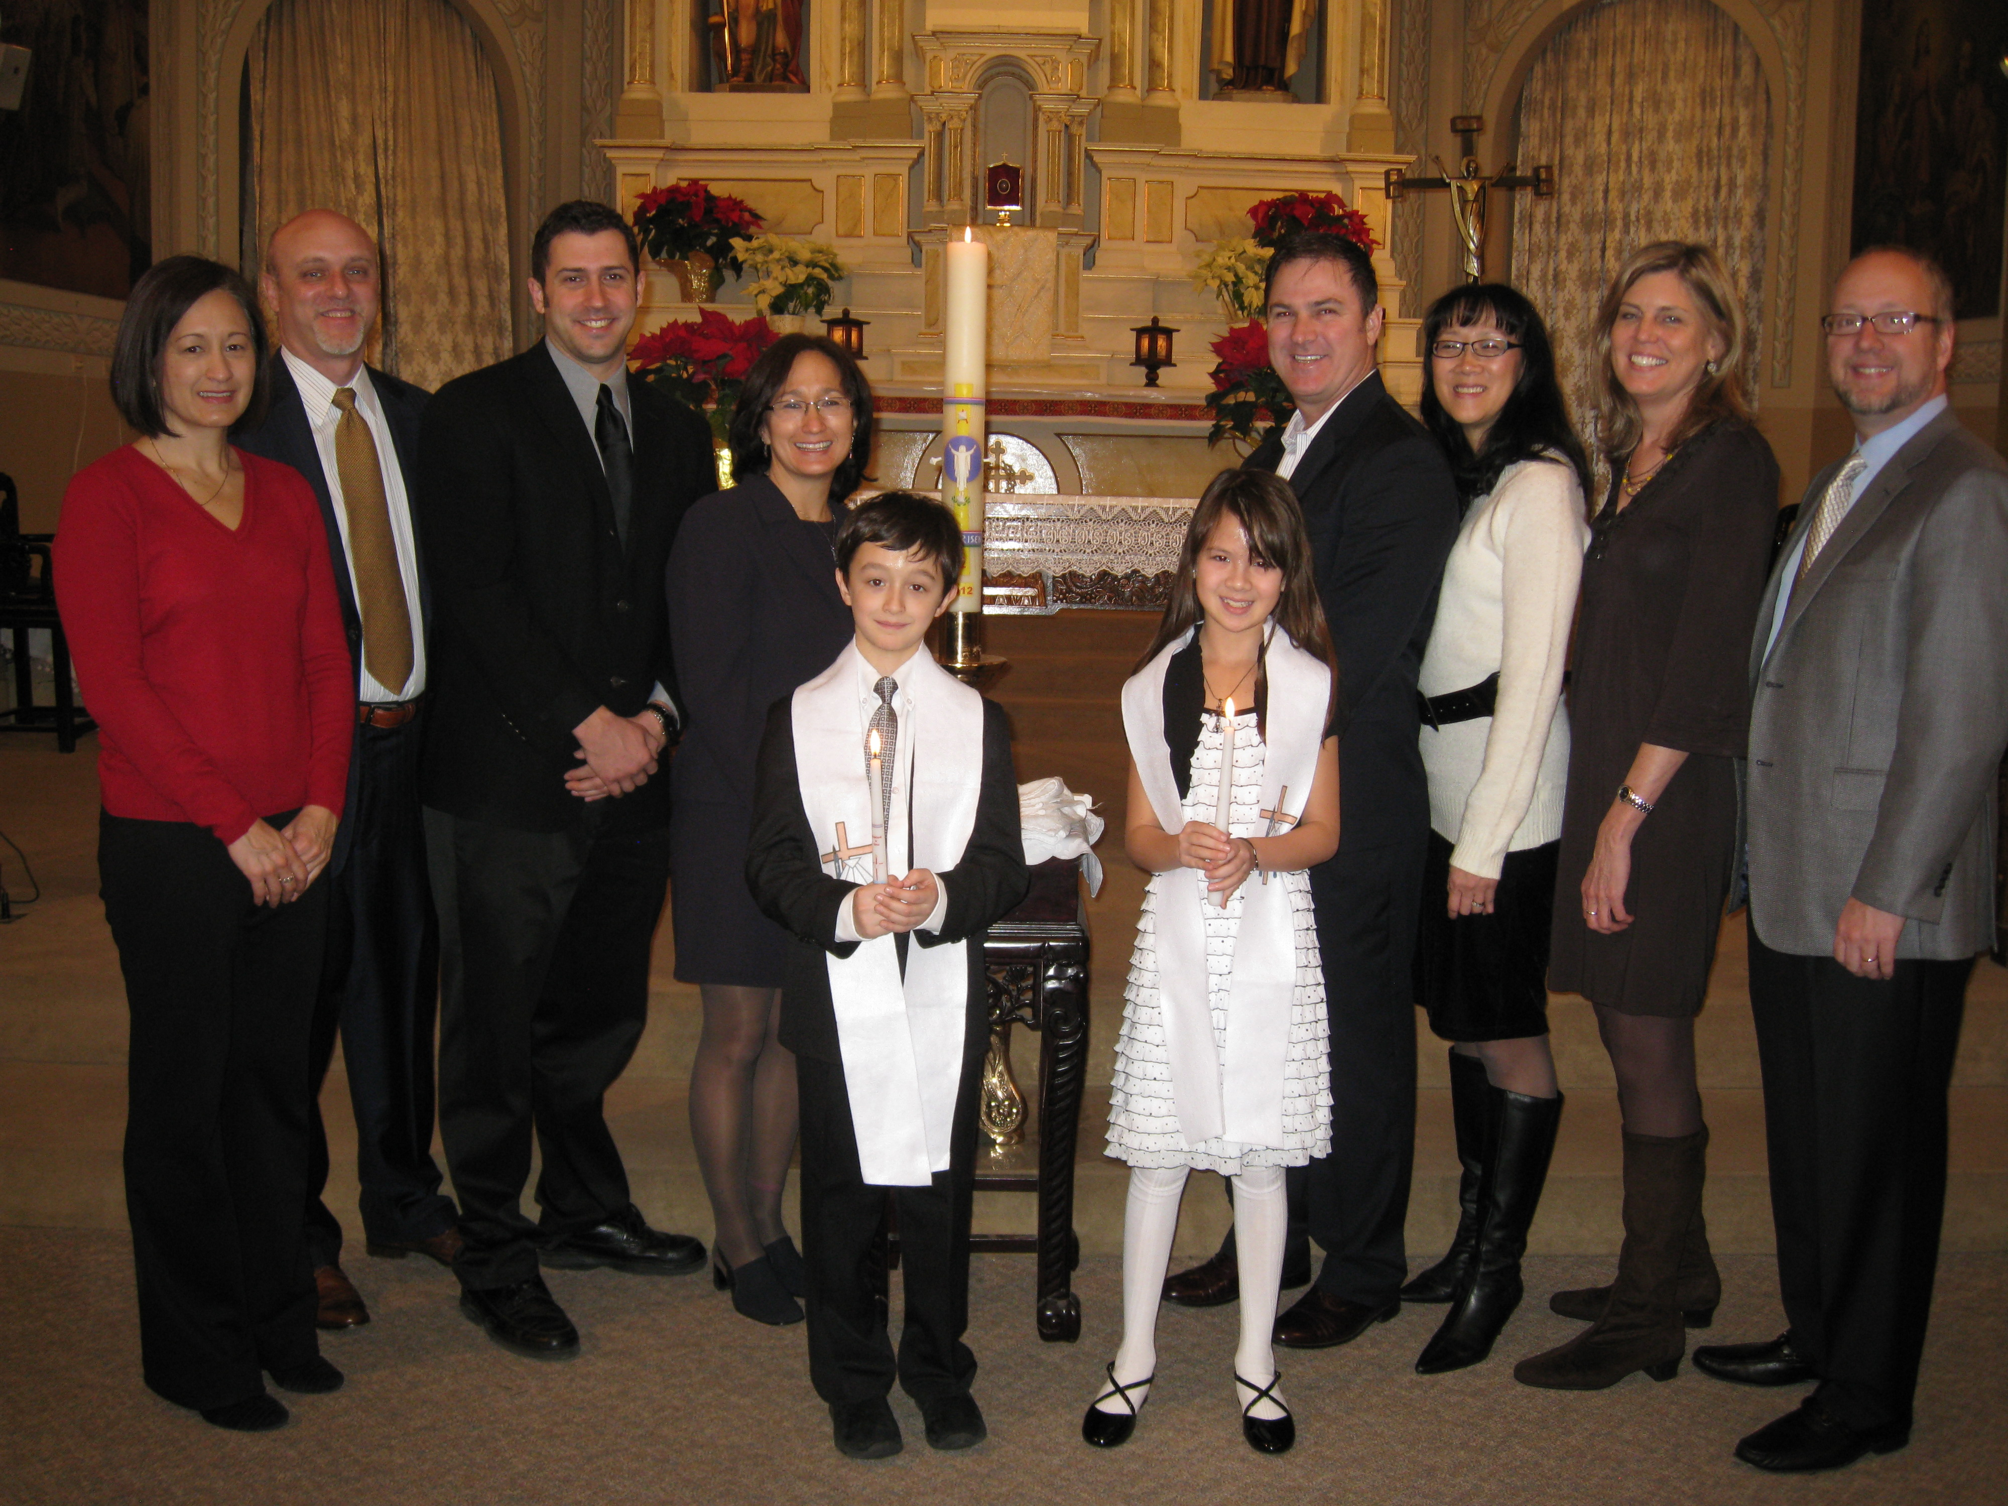

Congratulations and Thank You

Congratulations to Katelyn Schumacher, daughter of Craig Schumacher and Gloria Lee, and Robert Novak, son of Ken Novak and Carla Nelis. Both Katelyn and Robert were baptized at our Church last Sunday on the Feast of the Baptism of the Lord. They were born on the same date and year, and they are classmates at our school. We welcome them to our faith community! Please keep them in your prayers.

Thanks to Mr. and Mrs. Shu Man & Florence Yu for generously and thoughtfully donating $600.00 toward our Lunar New Year celebration, which will take place on Sunday, Feb. 17th, at the 9:30am Mass. We are happy that Bishop Alberto Rojas will join us for this special occasion. Please reserve the date and plan to be at St. Therese in celebrating the Year of the Snake!

Week of Prayer for Christian Unity (Jan. 18 -25)

It is an annual celebration sponsored by the Pontifical Council for Promoting Christian Unity and the World Council of Churches. During this week, Christians are especially encouraged to engage in personal prayer and join local joint observances.

This year’s theme is “What Does God Require of Us?” Our responses invite “Christians throughout the world to praise God and do justice, love kindly and walk humbly with God.” Below is a prayer for Christian unity:
O God, holy and eternal Trinity,
We pray for your church in the world.
Sanctify its life; renew its worship;
Empower its witness; heal its division;
Make visible its unity.

Lead us, with all our brothers and sisters
Towards communion in faith life, and witness
So that, united in one body
By the one Spirit,
We may together witness
The perfect unity of your love.

As we celebrate the Second Sunday in Ordinary Time, may we find time and space to “Deepen Our Faith in Christ” this week and in the Year of Faith. Peace, Fr. Francis

Hospitality Schedule for January 27, 2012
GREETERS: John Moy, Lushia Tie, Florence Yu
RECEPTION VOLUNTEERS: Eva Feng, Earl Hokens

♪♫ Choir Corner ♫♪
January 20, 2013—Family Mass
PROCESSIONAL: #435– 435 – SING TO THE MOUNTAINS
OFFERTORY: #726– MAKE ME A CHANNEL OF YOUR PEACE
COMMUNION: #842 - TAKE AND EAT THIS BREAD

Year of Sunday Mass

News and Events
Prayer Intention: Please pray for the repose of the soul of Josephine Parrilli, a longtime parishioner who was buried this past Tuesday, through St. Therese. May she rest in peace.

January 21st Meetings: Finance Committee at 5:30pm. and Liturgy Committee at 7:00pm.

Baptism—Nathan Lau will be baptized on Jan. 26th at 4:00pm.

Cantonese Bible Study Group—January 26th at 5:45pm to 9:00pm.

2013 Annual Catholic Appeal
St. Therese’s 2013 Target is: $8723.
Announcement Weekend: Jan. 26 and 27th; Commitment Weekend: Feb. 2 and 3
Follow-Up Weekend: Feb. 9 and 10
The theme of this year’s Annual Catholic Appeal is taken from St. Paul’s first letter to the Corinthians, LOVE NEVER FAILS

Reflections & Questions on Sunday Mass
As the Year of Sunday Mass continues to unfold, our Parish Pastoral Council invites all parishioners to actively participate in our Sunday celebrations, and to reflect on what Sunday Mass really means to each of us. You are invited to share your reflections in our weekly bulletin or simply ask a question about Sunday Mass, to be answered by our priest and pastoral staff. Please keep your reflection to half page and submit it or questions to:
office@sttheresechinatown.org

St. Therese School Annual Chinese New Year Benefit All are cordially invited! Date: Sat, Feb. 23rd at Furama Restaurant. Reception: 5:30pm; Dinner: 6:30pm; Music & Dancing: 9-10:30pm. Tickets: $80 (13 yrs. & up), $45 (3-12 yrs.). For more info and to register, see flyers on the church entrance table and visit our website: www.StThereseChicago.org
Let’s support our school!

Church Stained Glass Window Repair Appeal
Due to old age, our church window frames and parts of the damaged stained glass are
in great need of care and repairs. These stained glass windows add much beauty to our church and are part of the precious history of this parish, as all were donated by parishioners of decades ago.
To prevent further deterioration, we have engaged a firm to repair all 20 of these stained glass windows to bring them back to good form. The average repair cost is around $1,900 per window.
We need your support for this project. If you would like to make any donations toward the window project, please mark your contributions with “Window Repairs.” Thank you to all who have already made a donation:
Paul and Cindy Lau: $1000
James and Akina Moy: $1000
Dan and Pam Spano: $80
Shu Man and Florence Yu: $300
Chris and Darlene Lowe: $500
N. N.: $200
N. N.: $100
Sacred Heart Ladies Club: $1000
The May Family: $2000
Betsy Young & Woodie Lee: $50
Wanda Stearns: $50
Lucille Salerno: $100
Santa Maria Incoronata : $ 1000
Albert & Bernie Wong: $200
Rose Cho: $2000
Dominic Lai: $380
Robert Lee: $10
Larry A. Pusateri : $500
Eugene & Geraldine Kwan: $100
Gene & Teresa Lee: $200
Gary & Linda Leong: $200
Wesley & Sharon Wong: $100
Sandra Moy: $100
Sharon Yu: $1000
Ray Lin (The Lin Family) $500
Mr. & Mrs. William Moy $50
Andrew & Eva Feng $1900
Fr. Francis Li $100
Francine Caruso $100
Bonnie Tse $100
Kevin Wu (Sweet Stations) $100
Frank S. Scuito $100

BULLETIN TOTAL AS OF 01/16/13: $15,120
A plaque of remembrance will be placed in the church in gratitude to all the donors at

Super Duper Bowl
Roe v. Wade 40th Anniversary Letter
Weekly Offering:

Collection for January 13, 2013

Sunday Envelopes $1,614
Sunday Loose $ 249 July 1-To-Present (Actual): $57,107
Total Collection $ 1,863 July1-To -Present (Budget): $58,000

Weekly Budget: $2,000 % of Budget Attained: 98%
Please consider giving one hour of your weekly salary as your contribution.
May God bless your generosity! Thank YOU!
Indonesian Mass of January 13, 2013: $75.00 Thank YOU!
Good News! / dear Padre

Please remember in your prayers those who are
ill, hospitalized, and homebound...
Sarah Phillips Marie Balestri Carmella Scanlon
Natasha Chang Lucille Iasillo Carmen (Rails) Balestri
Dominic Barbaro Winnie So Vincent Thome
Barbara McElroy Barb Davis Rose Perez
Ramona Zavala Ken Barber Nicholas Tobar
Michael Howley Lauren Mandel Ruth Barone
Bernie Presto YoYo Damico Dolly Roti
Lina Andriacchi Baby Jessa Piotrowski Sister Noel Devine
Su Zhen Liao Fr. Walter Johnson, MM Michele Young
Sister Elizabeth Lee John Galvin Wu Wai Hing
Barbara Maung Lan Ying Yee Jane Lee
Shirley A. Bills Roseann Gurgone Carolyn Fields
John Palenik David Leung Alice Young
Frank Nardi Bai Xue Ching Siu Yau
John Piegari Richard Tobar Sister Agnes Christina
Leonard Louie Betsy Young Joseph Leung
Pam Ecklund Mary Balestri

If you wish to add a name or remove your name from this list, please call the parish office.

“Do Whatever He Tells You.”
Water is one of the very basic elements of our lives. Our world is filled with bodies of water many of which are undrinkable or perhaps polluted. Without water living beings die. When we do not water flowers they die. If we do not drink enough fluids we can end up in the hospital with dehydration problems. Water is a needed element of life but we often take it for granted. With Lake Michigan near us we think we have an endless water supply.

Today’s Gospel tells us about a wedding, wine, water and a Mother’s request. Mary recognized the need the wedding party had for more wine. There was none left to serve the guests. The lack of wine would bring the party to an end and would be a major embarrassment to the newly married couple. Mary went to her Son. With all surety that He would act despite His answer to her, she told the servants to do whatever He said. She did no more. She trusted in Jesus.

Jesus took the simple water jars and had them refilled with water. When the water was shared with the headwaiter, it was wine. The headwaiter was delighted as were the rest of the wedding guests. No one even knew there could have been a problem.

Our everyday lives are filled with many simple things. The gifts we bring, the actions and kindnesses which fill our lives do not seem like wine but much more like water, ordinary. If we follow Mary’s directive each day and “Do whatever Jesus tells us”’, our ordinary lives of everyday water will be transformed by Him into the life giving wine of generous service to God and each other. Mary will not have to say, “ Son, they have no wine.” Life giving gifts will be plentiful and will effectively build up the Body of Jesus in today’s world. Trust Him and Go, “Do whatever He tells you.” ~Sr. Caritas
Ads

Christmas 2012 Donations as of January 16th, 2013
Thank you to all who contributed!

Addition since 1/13/2013 Bulletin: $240
Michelle Solis $20
Mary Anne Nardi $200
Catherine Chan $20
$240 +(21,648 on 1/13/13)

TOTAL AS OF JANUARY 16th, 2013: $21,888

“The disciple simply burns his boats and goes ahead. He is called out… The old life is left behind, and completely surrendered. The disciple is dragged out of his relative security into a life of absolute insecurity… out of the realm of the finite… into the realm of infinite possibilities.”
Dietrich Bonhoeffer

WELCOMING RETURNING CATHOLICS to

St. Therese Chinese Catholic Church

If you are a Catholic who has been away from the Church, know that we are thinking about you. We invite you to be an active part of us again.

LANDINGS is a program that offers “a safe place to land”, a place for listening and for being heard, a place for asking questions and for reconnecting with the faith as an adult.

During the eight-week LANDINGS program, a small group of active Catholics, some of them “returnees” themselves, meets with a small group of inactive or returning Catholics to share and explore their faith together.

If you are interested or know of anyone who would like to become an active Catholic again, please contact Sr. Anji Fan or Cita Orendain at
landingsatsttherese@gmail.com or call the parish office at 312-842-6777.

