Mass Intentions

March 10, 2013 - Fourth Sunday of Lent

8:00A.M. + Vincent and Mary Bertucci by Zito’s

9:30A.M. + Carolyn Fields by Brian, Ed, Mary Ann, Marty, Sam & Wendy
+ Martha Holmes by Darlene and Family

11:00A. M. Indonesian Mass

MON. March 11th Lenten Weekday

8:00A.M. + Gonzalo Bunag II by Cita dn Daughters

TUE. March 12th Lenten Weekday

8:00A.M.

WED. March 13th Lenten Weekday

8:00A.M. + Poor and Forsaken Souls in Purgatory by Dominic Barbaro

THU. March 14th Lenten Weekday

8:00A.M. + Fred Roti - 5th Anniversary by Marion

FRI. March 15th Lenten Weekday

8:00A.M.

SAT. March 16th Lenten Weekday

8:00A.M. Birthday Blessings for Jenping Chan by daughter Darlene + Boon Man Lee by Rose Lee & Family

5:00P.M. Friends and Parishioners of St. Therese

From the Desk of Fr. Francis
Greetings of Christ’s Peace and Joy! Hope you all had a blessed week.

Thank You
Thanks to all who helped with folding and stuffing our Easter mailing envelopes this past Monday: Lucy Moy, Rose Lee, Monica Lam, Mary Chan, Cita Orendain, Cathy Lindfors, Mary Chen, Jay McMahon, and Rose Lau.

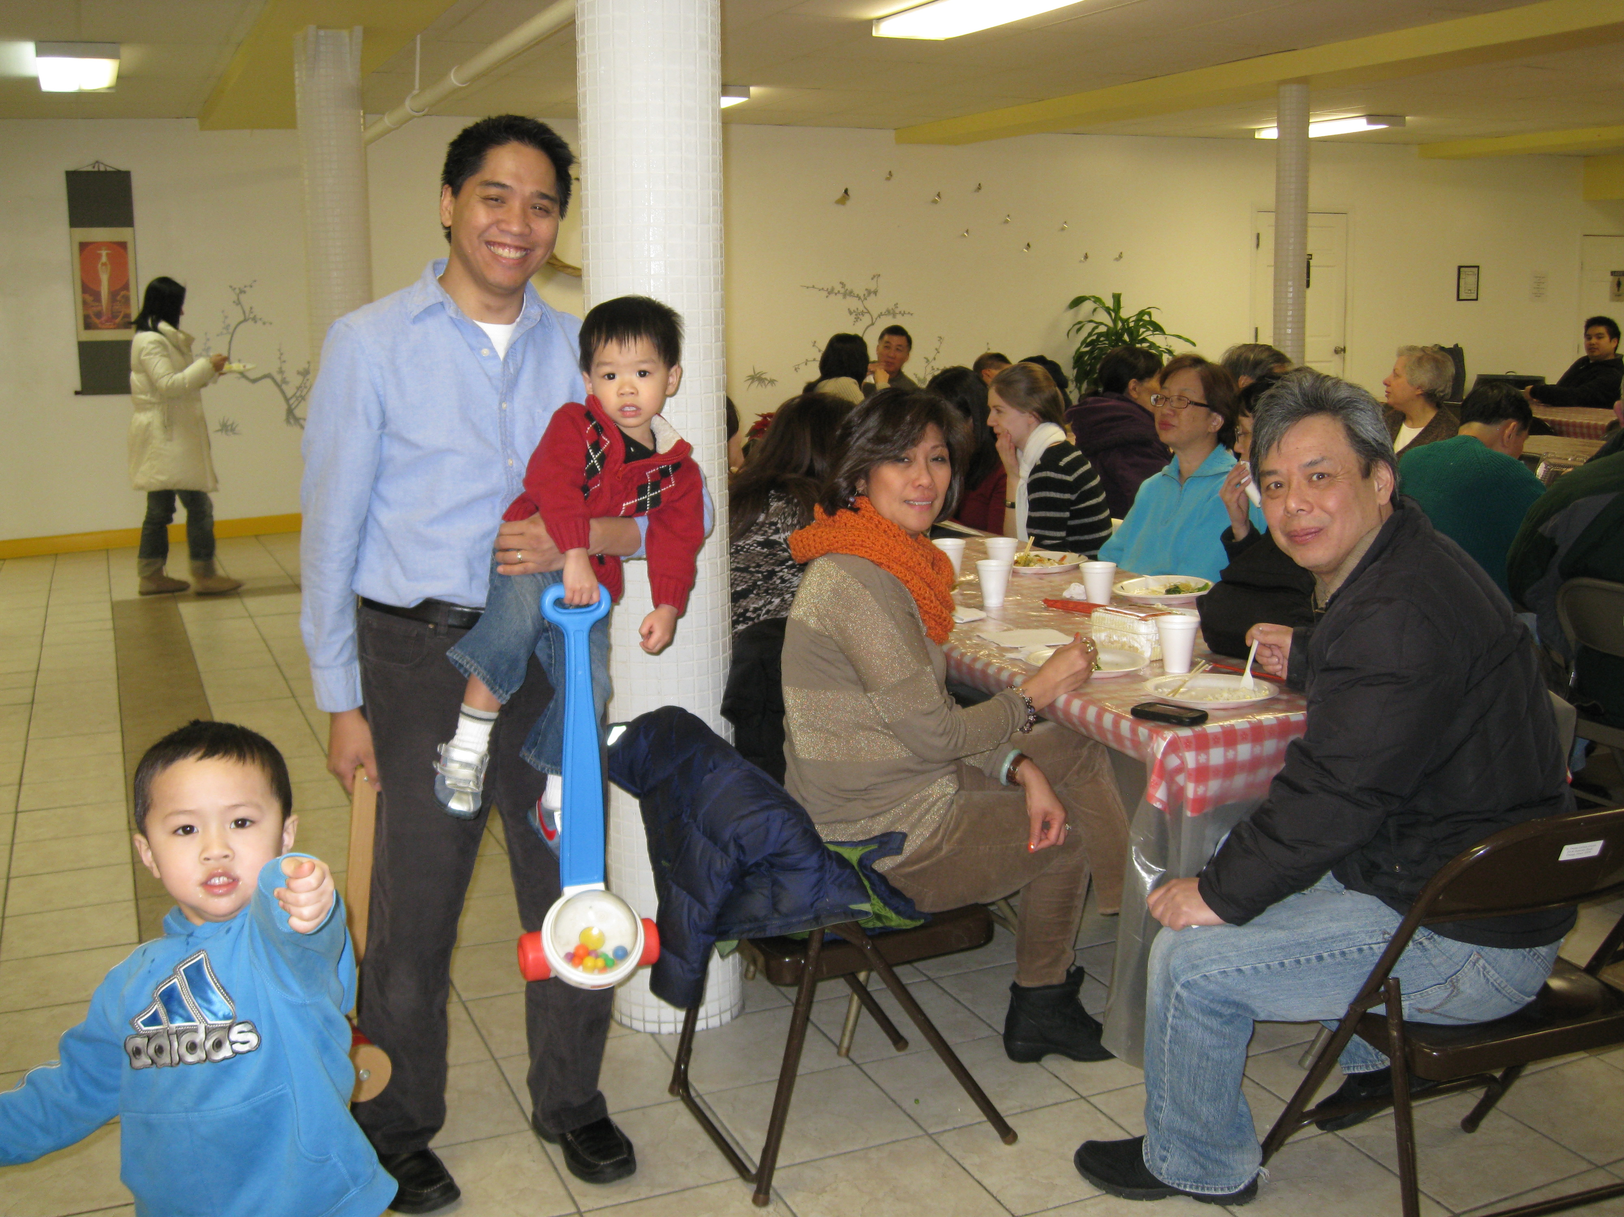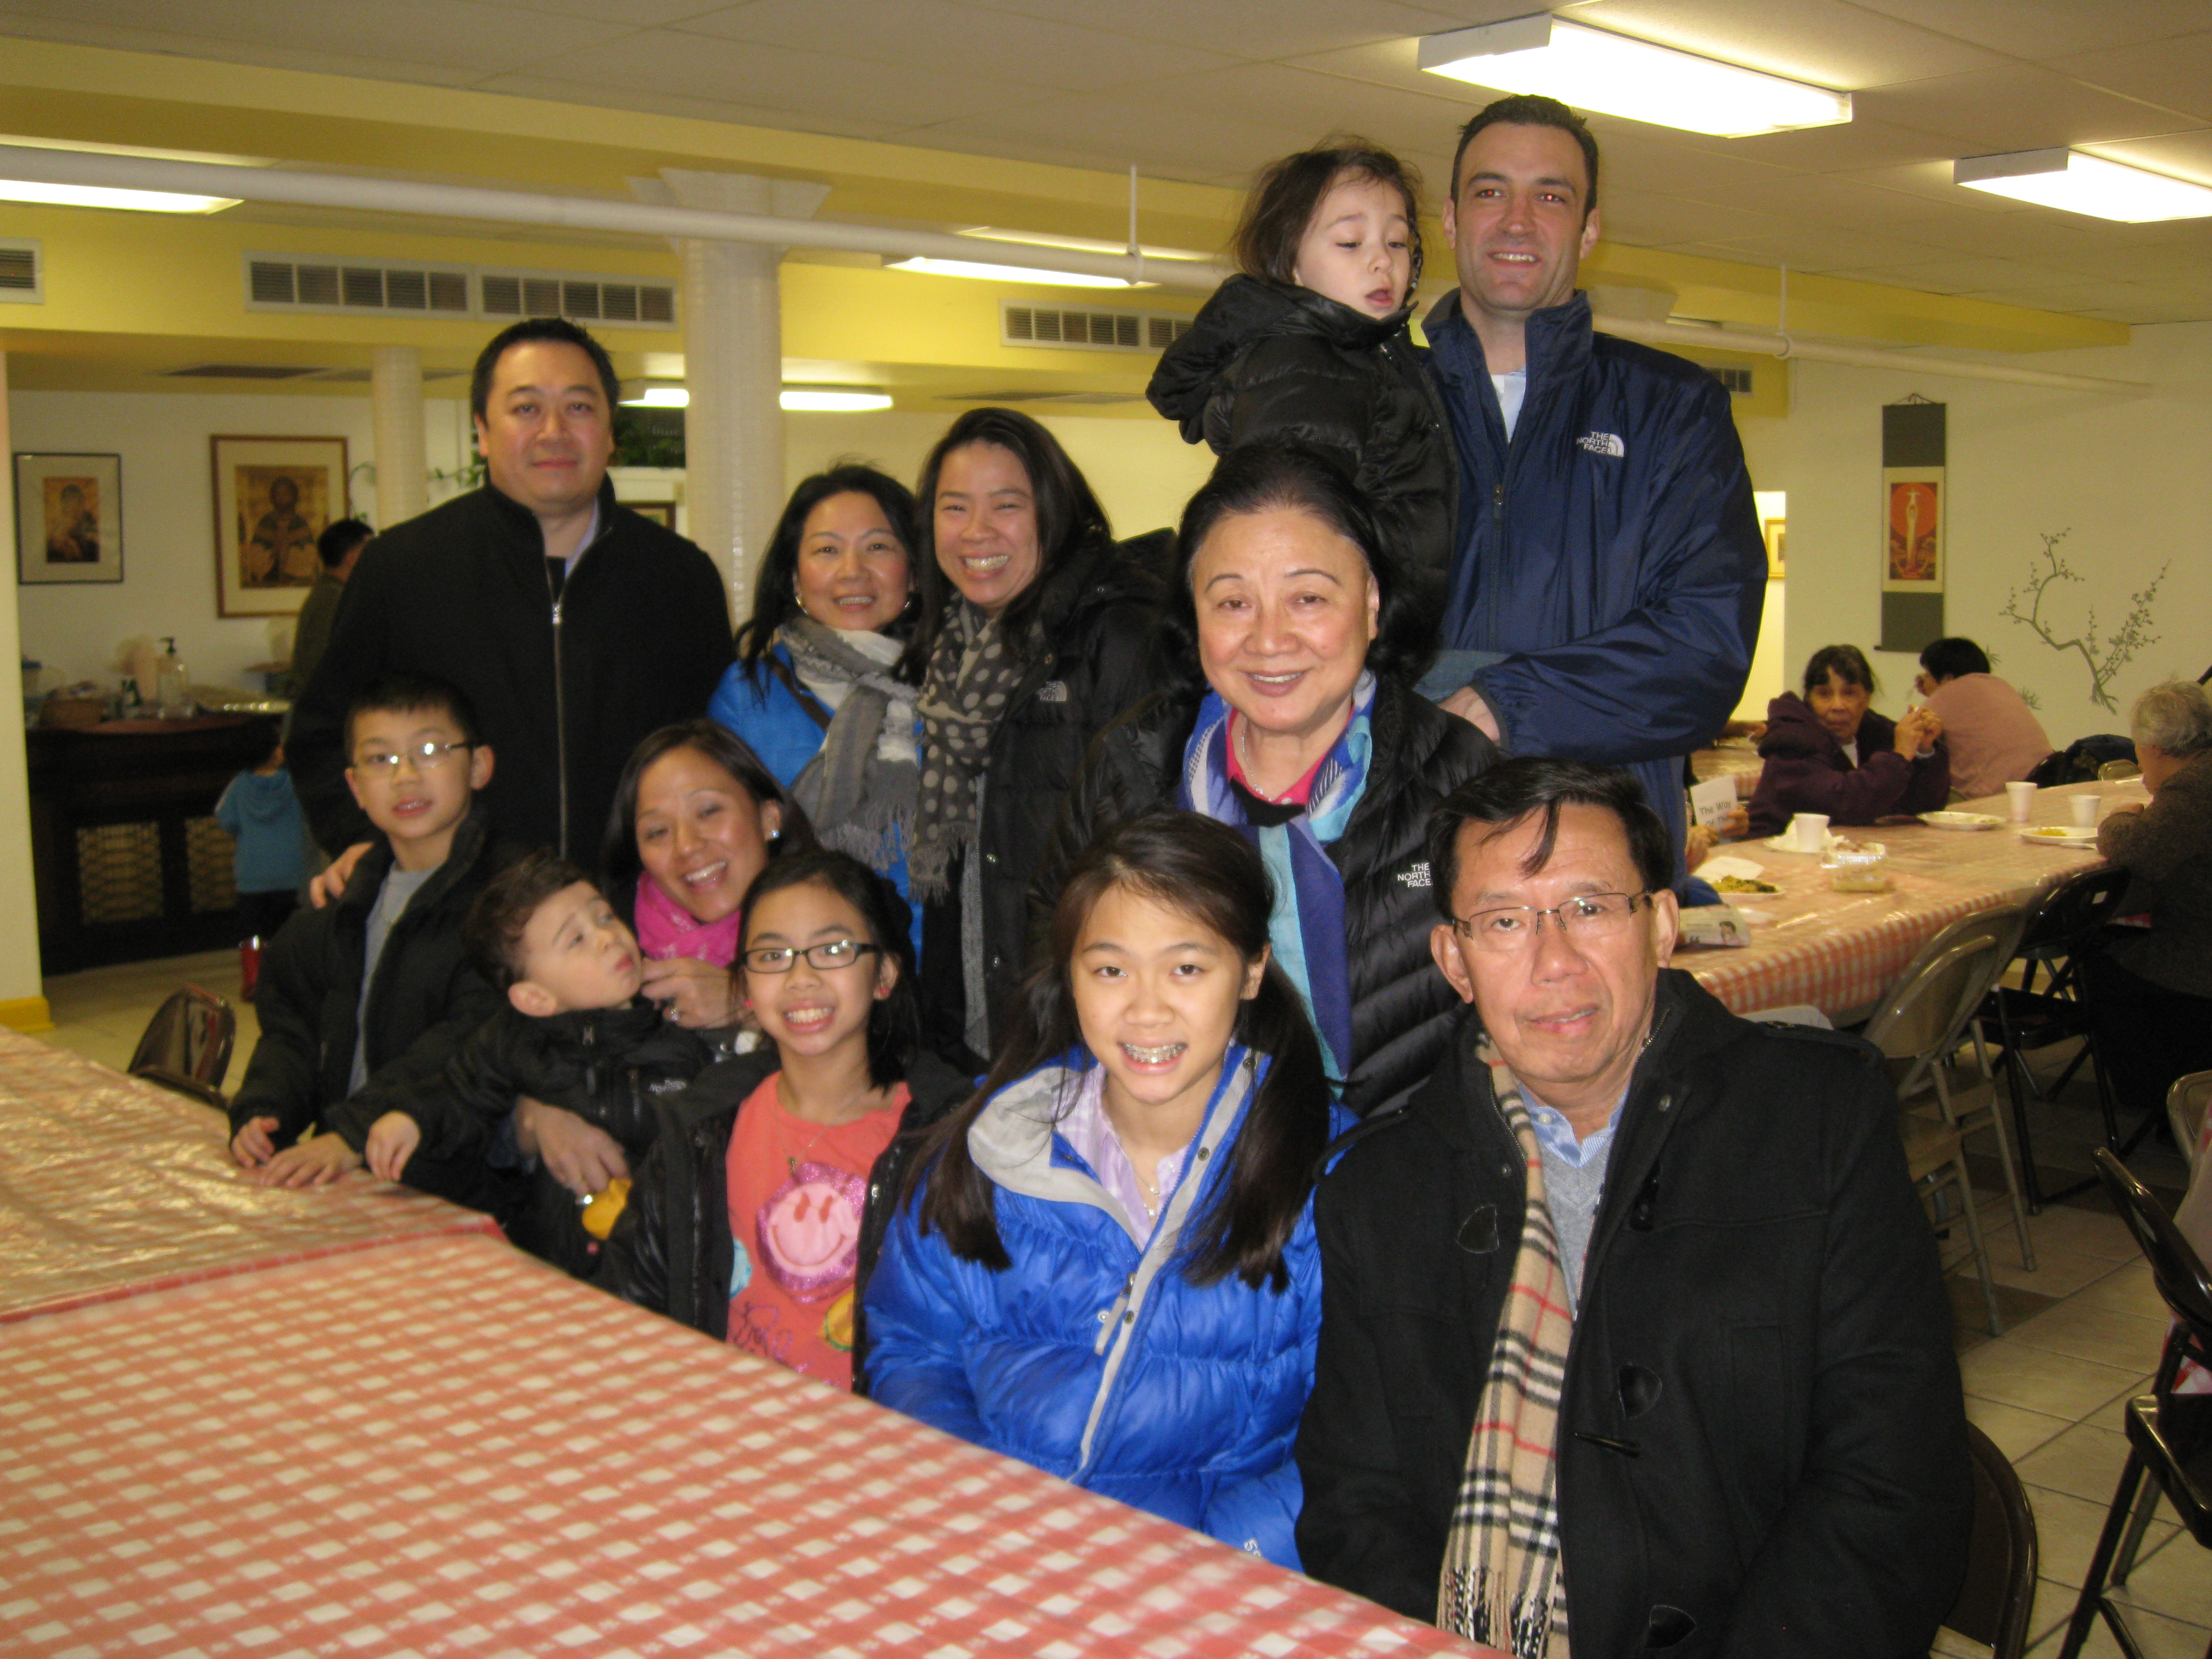

(Oi Family Members at the Dinner– left photo)

(Parishioners enjoying Food & Fellowship-right)
Thanks to Mr. and Mrs. Chuck Oi for donating plenty of delicious food for our Fish Fry dinner on Friday March 1st.

10 Ways to “Deepen our Faith in Christ”
The last VIRTUS (A Program for Protecting God’s Children) online article is about the Year of Faith. Reading it offered me some concrete ways to practice my faith. The author of the article, Paul Ashton, citing Bishop David Ricken of Green Bay, Wisconsin, chairman of the Committee on Evangelization and Catechesis of the U.S. Conference of Catholic Bishops, lists “10 Ways Catholics Can Live the Year of Faith.” I quoted them below and hope they can enlighten your faith especially during this Lent and Year of Faith.

1. Participate in Mass. The Year of Faith is meant to promote the personal encounter with Jesus.
2. Go to Confession. Like going to Mass, Catholics find strength and grow deeper in their faith through participation in the Sacrament of Penance and Reconciliation.
3. Learn about the lives of the saints. The saints are timeless examples of how to live a Christian life, and they provide endless hope.
4. Read the Bible daily. Scripture offers first-hand access to the Word of God and tells the story of human salvation.
5. Read the documents of Vatican II. The Second Vatican Council (1962-65) ushered in a great renewal of the Church
6. Study the Catechism. Published exactly 30 years after the start of the Council, the Catechism of Catholic Church covers the beliefs, moral teachings, prayer & sacraments of the Catholic Church in one volume.
7. Volunteer in the parish. The Year of Faith can’t be only about study and reflection. The solid grounding of the Scriptures, the Council, and the Catechism must translate into action.
8. Help those in need. The Vatican urges Catholics to donate to charity and volunteer to help the poor during the Year of Faith.
9. Invite a friend to Mass. A personal invitation can make all the difference to someone who has drifted from the faith or feels alienated from the Church.
10. Incorporate the Beatitudes into daily life. The Beatitudes (Matthew 5:3-12) provide a rich blueprint for Christian living.

Maybe some of the listed things above you are already doing. Maybe you can choose one or two more to give a try. Maybe you can find time to try all of them and more. Bishop Ricken’s full article is available online: http://www.usccb.org/news/2012/12-150.cfm
This weekend after mass, you are invited to receive a prayer card titled: Increase our Faith, from our greeters. Praying is another indispensable way to practice our faith.
~Peace, Fr. Francis
Hospitality Schedule for March 17, 2013
GREETERS: Rose Marie Lau, Samantha Ng, Florence Yu
RECEPTION VOLUNTEERS: Gemma, Linda, Teresa

♪♫ Choir Corner ♫♪
March 10, 2013 – Fourth Sunday of Lent
Accompanist: Angel Hau
PROCESSIONAL: #388 - THE GLORY OF THESE FORTY DAYS
OFFERTORY: #387 – HEAR US, ALMIGHTY LORD
COMMUNION: # 399 – DEEP WITHIN
RECESSIONAL: #626 – THERE’S A WIDENESS IN GOD’S MERCY

Year of Sunday Mass

Rice Bowls will be collected— at all the masses next weekend March 17th. Please remember to bring them to Church.

Second Collection Today is for the Church in Central and Eastern Europe.

Confession for CCD Students—today from 10:45am to 12:30pm followed by rehearsal for CCD’s First Reconciliation Students.

CCD Pancake Breakfast will take place next Sunday after the 9:30A. M. mass. Proceeds from it will be donated to a charitable organization (TBA).

The United States Council of Catholic Bishops Postcard Campaign— The St. Therese Respect Life Ministry is participating in this campaign to (1) Prevent federal funding and promotion of abortion and (2) Protect rights of conscience in health care.
At all masses this weekend, ushers will distribute notes addressed to your senators and congressman that need your signature and address, if you wish to participate in this campaign. If you did not get one, there are some on the church entrance table. If you do not know your congressman’s name, we will fill it in for you. After affixing your signature and address to all three notes, please deposit them in the baskets at the entrance or give them to an usher. Members of the Respect Life Ministry will be at the church entrance to answer your questions immediately after mass. They will also gather and mail the notes to Washington.
If you are interested in Respect Life Ministry activities and/or if you have suggestions for the Ministry, please put down your contact information on the Respect Life sign-up sheet on the table at the church entrance.

Parish Pastoral Council Meeting— On Tues., March12th at 7:00pm in the Community Room.

School Rehearsal for Living Stations—in Church on Wednesday, March 13th & Friday, March15th from 3:30pm to 5:00pm.

First Reconciliation Rehearsal for School Children—on March 15th at 1:30pm

Reconciliation for St. Therese CCD and School children—at 10:00am in Church on Saturday, March 16th.

ST. THERESE SCHOOL NEEDS OUR VOTES!!! OUR CHILDREN NEED YOU!!! We are in 7th Place. Can we move up with your help? Only YOU can decide that with your vote! We have only 13 days left! It TAKES 30 seconds NOW. We CAN DO THIS! Let’s pull together to get the votes to secure a solid position. $60,000 is at stake! Please help our school for a chance to win $60,000 from the Follett Grant. Please vote each day through March 18th and encourage others to vote as well. It’s easy to do! How to vote:
1. Go to www.follettchallenge.com
2. In the search type, "St. Therese School". You should see "St. Therese School: Little School Big Dreams" video. CLICK on this.
3. On the right, you need to enter your email address. Click to submit.
4. Then you need to confirm your vote through an email sent to your email address.
Thanks for your support!

Experience The Stations of the Cross online! There are two ways to check it out:
Visit the Official site: http:experiencethestations.com
View directly on YouTube:
http://youtu.be/_eFdXHi6tWE
Hope this video serves as a source of reflection and strength for you in the Lenten season.

Tax Letter—if you would like to receive a tax letter for your 2012 donations to St. Therese, please contact the office at 312-842-6777.

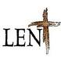

2013 Updated

“Deepen Our Faith in Christ”

Stations of the Cross
Fridays at 7:00P.M.in Church preceded by dinner in the Community Room at 6:00 P.M.

Sharing on The Eucharist
Fridays at 7:45P.M. following the Stations of the Cross in the Community Room
Service
Sisterhouse (date TBA). Volunteers are needed.

RCIA
*Scrutiny Rites will be celebrated on the 3rd, 4th and 5th Sundays of Lent.
CCD
*Reconciliation will take place on Sunday, March 10th after the 9:30A.M. Mass.
*CCD students Lenten project on Sunday March 17th

First Reconciliation
For CCD and School students will take place on March 16th at 10:00A.M.

Parish Retreat and Communal Reconciliation
“Prayer & Reconciliation” led by Sr. Caritas
Date: Saturday, March 16th from 10:00A.M. to 3:00P.M. at the Catholic Theological Union, 5416 S. Cornell, Room 335. Communal Reconciliation will follow. Suggested donation: $10. Parking: If there is no street parking, parking is available at CTU for
$5 per car for the whole day. Carpooling suggested. If you are attending and need a ride please indicate on the sign up sheet at the church entrance table no later than Wed.,
March 13th. Babysitting is being arranged at St. Therese if anyone with children would
like to participate and need a sitter. See Sr. Caritas or Cita Orendain for more info.

March Mandarin Mass
Will be on March 24th followed by an afternoon of reflection and prayer.

Cantonese Lent Recollection
When: Sunday, March 24th from 11A.M. to 12 noon
Topic: The Seven Last Words of Jesus Christ
Where: Santa Maria Room
Speaker: Sr. Mary Lou Rajdl
All are invited! Please sign up at church entrance table if you plan to attend.

REPENT, AND BELIEVE IN THE GOOD NEWS!

Weekly Offering:

Collection for March 3, 2013

Sunday Envelopes $1,889
Sunday Loose $ 249 July 1-To-Present (Actual): $72,618
Total Collection $2,138 July1-To -Present (Budget): $72,000
Weekly Budget: $2,000 % of Budget Attained: 101%
Please consider giving one hour of your weekly salary as your contribution.
May God bless your generosity! Thank YOU!

Church in Central and Eastern Europe Collection

Good News! / dear Padre

Ads

Please remember in your prayers those who are
ill, hospitalized, and homebound...
Sarah Phillips Marie Balestri Carmella Scanlon
Natasha Chang Lucille Iasillo Carmen (Rails) Balestri
Dominic Barbaro Winnie So Vincent Thome
Barbara McElroy Ken Barber Rose Perez
Ramona Zavala Lauren Mandel Nicholas Tobar
Michael Howley YoYo Damico Ruth Barone
Bernie Presto Baby Jessa Piotrowski Dolly Roti
Lina Andriacchi Fr. Walter Johnson, MM Sister Noel Devine
Su Zhen Liao John Galvin Michele Young
Sister Elizabeth Lee Barbara Maung Wu Wai Hing
Shirley A. Bills Roseann Gurgone Lan Ying Yee
John Palenik Alice Young Frank Nardi
David Leung Ching Siu Yau John Piegari
Bai Xue Sister Agnes Christina Leonard Louie
Richard Tobar Joseph Leung Jean Toy
Betsy Young Mary Balestri
Jane Lee Pam Ecklund

If you wish to add a name or remove your name from this list, please call the parish office.

“This Man Welcomes Sinners and Eats with Them.”

Whenever we pick up a newspaper or listen to the news on TV, we learn of many evil things which are happening daily in our world. People are violent, money is stolen, politicians are accused of lying. Trafficking and prostitution are ignored. Some parents beat and kill their children. Gang territory can determine which public school we close. Drugs are openly sold on our street corners. Sinners seem to be everywhere. When we see people like this our instinct and goal are to avoid these people and situations. We put time, money and energy into avoidance and change. Many times all our efforts are to no avail. Nothing changes.

We are told that Jesus “welcomed” sinners and ”ate with them.” If Jesus were alive today, perhaps these would be the people he would be looking for, welcoming, eating with, sharing life with. If we saw Jesus with these kinds of people what would we think? Would we join Him? Would we judge Him, complain as did the Pharisees and scribes? Would we eat with Jesus and with sinners? Jesus was always Jesus. Whom He was with did not change His compassionate, loving heart. We, however, are often quick to judge.

One of the thing we need to remember is that we, too, are sinners. We may not have killed anyone or robbed anyone. We may not have physically harmed anyone but perhaps we have done things which have harmed someone’s spirit. Perhaps our example or actions did not help others. We ARE Sinners. If we judge ourselves as not sinners, we do not NEED Jesus. “ Come, welcome all sinners. Join Jesus at the table.” Know His compassionate, caring, forgiving love! ~Sr. Caritas

Church Stained Glass Window Repair Appeal
(Before) (After) Due to old age, our church window frames and parts of the damaged stained glass are in great need of care and repairs. These stained glass windows add much beauty to our church and are part of the precious history of this parish, as donated by parishioners of decades ago.
To prevent further deterioration, we have engaged a firm to repair all 20 of these stained glass windows to bring them back to good form. The average repair cost is around $1,900 per window. ***UPDATE:
The entire exterior work for our church window repair and broken stained glasses have completed. Unfortunately, this is not the end of the project. As with fixing up any old windows, there is a higher chance of surprise. It’s now been confirmed that we need to replace a few of the moon-shaped top window frames on the inside. With the additional work on the inside window frames, our estimated total cost of this project is now $55,000. We hope to complete the next phase of this work as soon as possible.
We need your support for this project. If you would like to make any donations, please mark your contributions with “Window Repairs.” Thank you to all who have already made a donation:

Paul &Cindy Lau: $2000 Francine Caruso: $100
James &Akina Moy: $1000 Bonnie Tse: $100
Dan & Pam Spano: $150 Kevin Wu (Sweet Station): $100
Shu Man & Florence Yu: $300 Frank S. Scuito: $100
Chris & Darlene Lowe: $500 Peter Blais: $50
N. N.: $200 Teresa Au: $50
N. N.: $100 Phyllis & Rose Marie Centofanti: $100
Sacred Heart Ladies Club: $1000 Wendy Fluder: $100
The May Family: $2105 Frank & Sophie Nardi: $500
Betsy Young & Woodie Lee: $50 Dominic Barbaro: $200
Wanda Stearns: $50 Richard & Rita Young: $200
Lucille Salerno: $100 Edy & Lisa Gunawan: $100
Santa Maria Incoronata : $ 1000 Annie Lowe: $100
Albert & Bernie Wong: $200 Menacita Chan: $100
Rose Cho: $2000 Gemma Wong: $200
Dominic Lai: $380 Jennifer Chan & Jorge Morales: $50
Robert Lee: $10 Tony Lin & Sharon Wong: $355
Larry A. Pusateri : $500 Wendy Sin: $500
Eugene & Geraldine Kwan: $100 The Tse Family : $53
Gene & Teresa Lee: $200 Renee & George Fong: $53
Gary & Linda Leong: $200 The Urso Family: $500
Wesley & Sharon Wong: $100 Gertrude Chan: $50
Sandra Moy: $100 Leonard & Elaine Louie: $1900
Sharon Yu: $1000 Joseph and Natia DiFazio: $100
Ray Lin (The Lin Family): $500 Lucille Salerno: $500
Mr. & Mrs. William Moy: $50 Joseph & Bernadette Zito: $100
Andrew & Eva Feng: $1900 Michael & Sevila Schiml: $150
Fr. Francis Li: $100 Mr. & Mrs. Francis Degnan: $75
Amy C. Floyd: $200 Mr. & Mrs. Vincent Briglio: $100
Karen L. Zewe: $50 Mr. & Mrs. John Lusak: $1000
Peter Tse: $100 Augustine & Donna Gonzalez: $200
Joe & Margaret Cabello: $100 Janet & Albert Moy: $300
Tony & Mary Ann Nudo: $100 Janet Fectau: $50
Marion B. Roti: $100

BULLETIN TOTAL AS OF 03/10/13: $24,681
A plaque of remembrance will be placed in the church in gratitude to all the donors at the end of the project.

