Mass Intentions

March 24, 2013 - Palm Sunday of the Passion of the Lord

8:00A.M.
9:30A.M. Health blessings for Sr. Mary Lou Rajdl and Sr. Gloria

11:00A.M. Mandarin Mass

MON. March 25th Monday of Holy Week

8:00A.M. For peace and justice by Hedy Zaremba

TUE. March 26th Tuesday of Holy Week

8:00A.M. + Carolyn Fields by Sr. Caritas Wehrman
+ Howard and Rose Marie Thome by Zito Family

WED. March 27th Wednesday of Holy Week

8:00A.M.

THU. March 28th Holy Thursday

7:00P.M. Evening Mass of the Lord’s Supper

+ Barry Yong by Mom, June Moy

+ Birthday Remembrance for Henry Lee by Wife, Children & Granddaughter

FRI. March 29th Good Friday of the Passion of the Lord

3:00P.M. Living Stations of the Cross by School Children

7:00P.M. Veneration of the Cross and Communion Service

SAT. March 30th Holy Saturday

7:30P.M. Easter Vigil Mass

From the Desk of Fr. Francis
Greetings of Christ’s Peace and Joy! Hope you all had a blessed week.
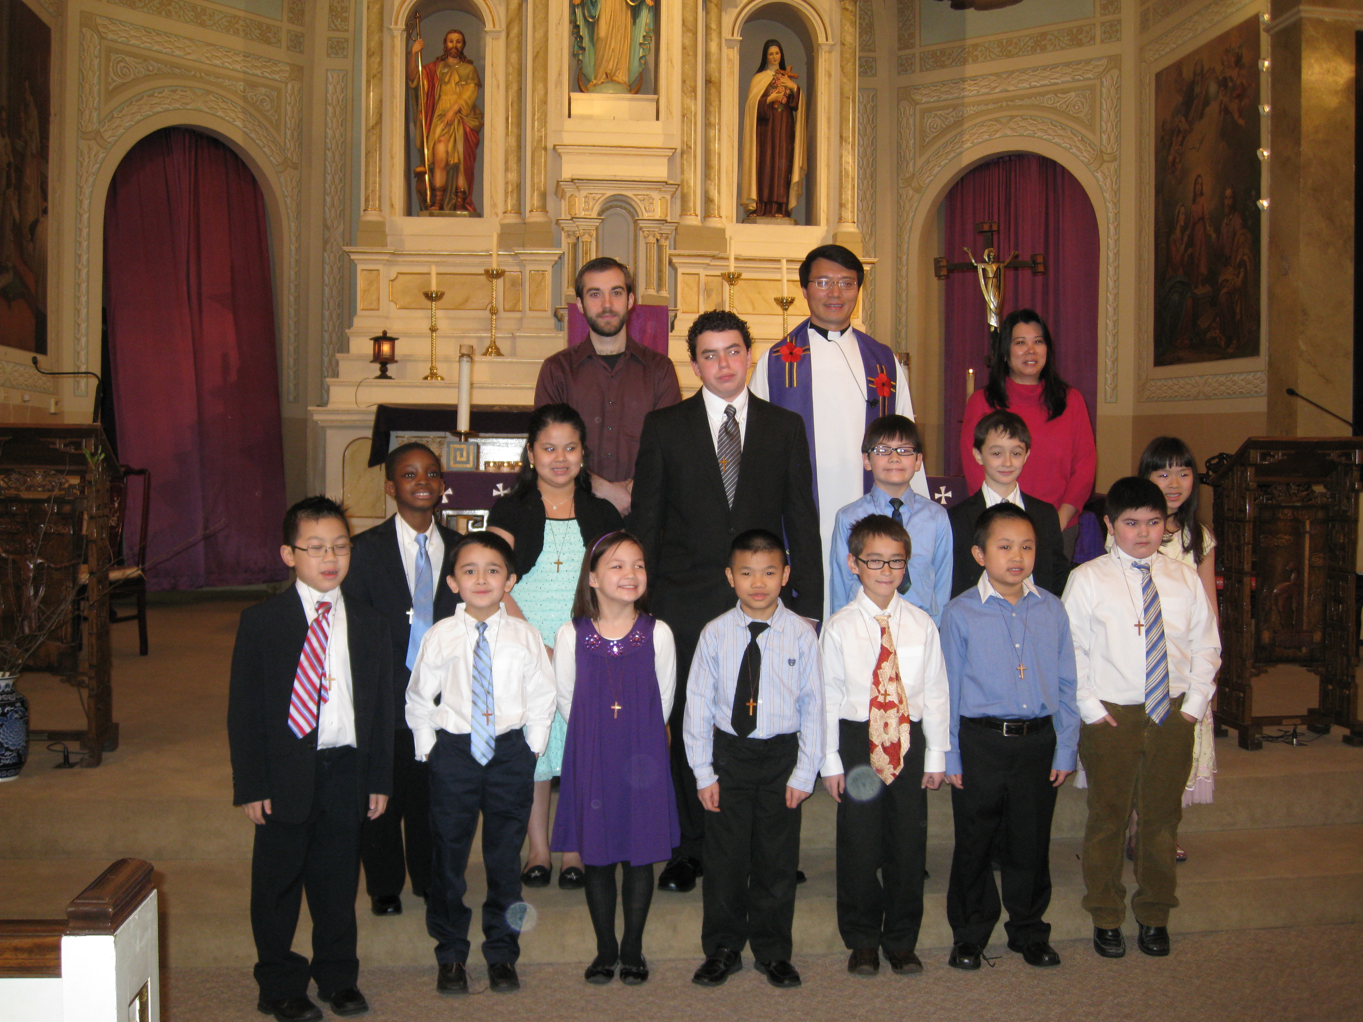

Congratulations and Thank You
Congratulations to our school and CCD students who celebrated their First Reconciliation on Saturday, March 16th, 2013:

Ephraim Balogun Caitlyn Lee
Ryan Daly Jason McGrath
Jacqueline Del Raso Alexander Moy
Lucy Harley Ethan Mui
Wyatt Harley Robert Novak
Ivan Hokens Matthew Schiml
Nathan Lau

Due to illness, Katelyn Schumacher wasn’t able to join the celebration. She will have her First Reconciliation on a later date. Thanks to their teachers and catechists for well-preparing our children for the celebration.

Thanks to Florence Yu for cooking plenty of delicious food for our Fish Fry dinner on Friday March 15th. Thanks to Sr. Caritas for leading our parish Lenten Retreat on March 16th and to all who attended it.

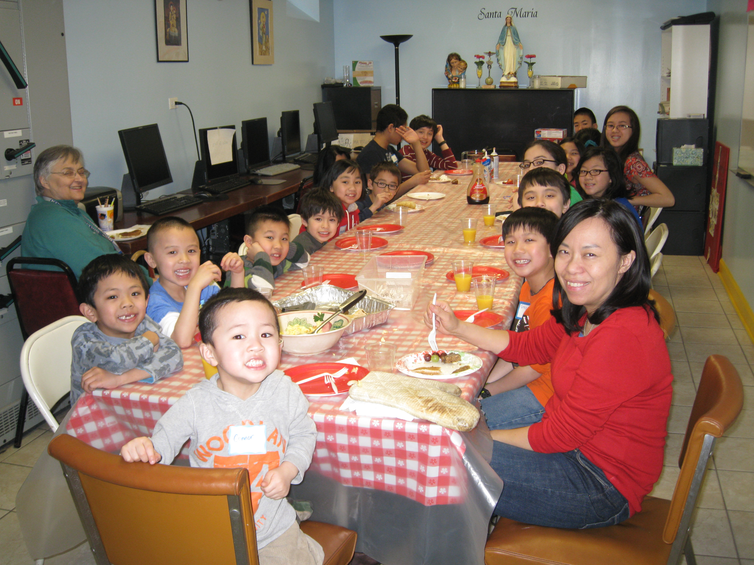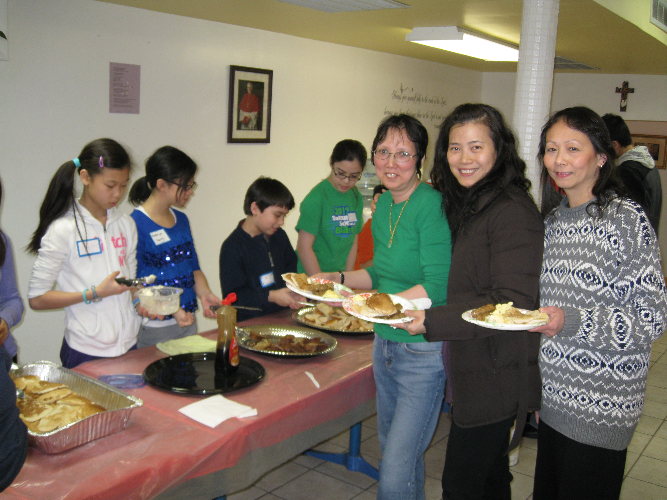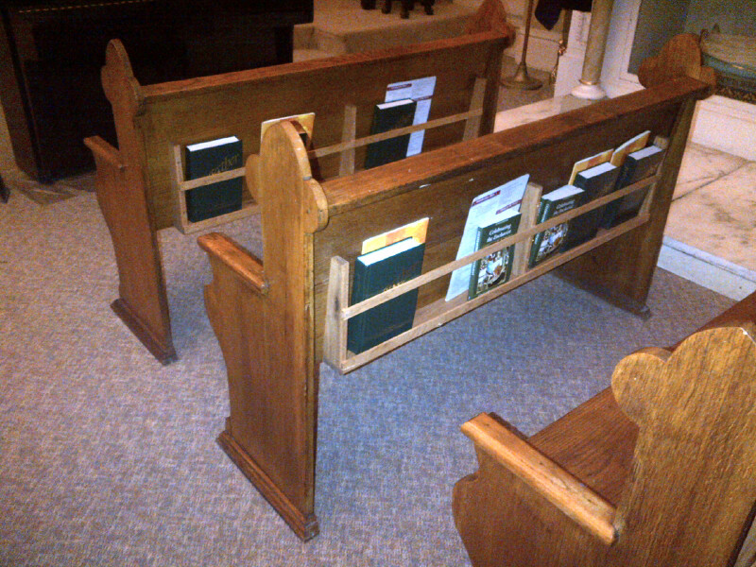

Thanks to our CCD students, their parents and catechists for hosting their pancake breakfast for a good cause. It’s a lot of work, but our children and adults had fun with their Lenten project. Over $400 were collected to help an After School and Summer School Program for disadvantaged kids run by the Sisters of Notre Dame, which Sr. Caritas is part of.
Thanks to Peter Blais for installing book holders on the back of the pews in our choir area. I know our musicians are also very appreciative of this. It helps them to place their materials nicely and keep the pews orderly.
Humility---Suffering---New Life

As we journey into Holy Week, the celebrations of the Last Supper, Passion of the Lord, and Resurrection of the Lord remind us of our call to courageously embrace our daily crosses and humbly experience the new life in the risen Lord. Holy Thursday, Good Friday, and Easter Vigil and Sunday offer us the most beautiful and solemn worship experiences in the Liturgical Year. There are a lot of gestures and symbols in these liturgies, which help us to touch both the divine and human life. The washing of the feet, veneration of the Cross, and the lighting of the candles, and celebrations of Baptism, Confirmation and First Communion affirm us of the true meaning of discipleship.

I invite you and your families to make some efforts to participate in the upcoming Triduum celebrations on Holy Thursday, Good Friday, Easter Vigil and Sunday.
~Peace, Fr. Francis

Year of Sunday Mass

Hospitality Schedule for Easter, March 31, 2013
GREETERS: Jean Ng, Bonnie Tse, Sharon Yu
RECEPTION VOLUNTEERS: Florence, Lushia, Nancy

♪♫ Choir Corner ♫♪
March 24, 2013 – Palm Sunday

PROCESSIONAL: #402- ALL GLORY, LAUD AND HONOR
OFFERTORY: #593 – WE REMEMBER
COMMUNION: #404 –JESUS, REMEMBER ME
RECESSIONAL: #791– LIFT HIGH THE CROSS

News and Events

Rice Bowls—You can still turn in your rice bowls this weekend.

Chrism Mass will be celebrated by Cardinal George on Tuesday afternoon March 26th at Holy Name Cathedral. Two parishioners from each parish of the Archdiocese are invited to participate. If you would like to go, please ask Fr. Francis for tickets.

Living Stations Practice—in Church at 3:30p.m. to 5:00p.m. on Tuesday, March 26 and Wednesday, March 27.

Church Decoration—on Wed., March 27 at 6:00p.m. , we will decorate for Holy Thursday. Dinner will be provided. If you can help, please sign up at the church entrance table. On Sat., March 30 at 10:30a.m., we will decorate for Easter. Lunch will be provided. Please sign up in order to help us to prepare enough food.

RCIA Rehearsal—on Saturday, March 30 at 10:00a.m.

Washing of the Feet on Holy Thursday (March 28th)—As part of our Lenten tradition, we imitate Jesus’ example of washing his disciples’ feet. This is an act of humility and a great example of service. We need twelve people to participate. If you can, please sign up on the sheet at the church entrance table.

WAY OF THE CROSS THROUGH DOWNTOWN CHICAGO —on Good Friday, March 29th. Gathering at 8:45 A.M. at Daley Center Plaza on Dearborn & Washington to end at 12:00 noon at Holy Name Cathedral (State & Superior). Walking in silence following the Cross, with 5 stops for songs, meditations and readings from the Passion. “...WILL YOU FORSAKE HIM THEN FOR ANOTHER LOVE?” Everyone is welcome. For more information please visit www.wayofthecrosschicago.org.

Collection for Holy Land—Christians around the world are united in a special way during Lent, Holy Week and Easter. Our hearts, minds and prayers are also especially aware of the Holy Land.

On Good Friday, our parish is called on to support Christians in the Holy Land. Many Christians in the Holy Land depend on the collection for their lives.

As a pontifical collection requested by Pope Benedict XVI, the annual Good Friday Collection offers a direct link for parishioners to be witnesses of peace and to help protect the Holy Places. When you donate on Good Friday, you are supporting Christians in the Holy Land.

Franciscans and others in the Holy Land are housing and feeding the poor, providing religious formation and education, maintaining shrines and parishes, and conducting pastoral ministry. For more information, visit: www.myfranciscan.org.

The Good Friday Collection is requested by the Holy Father. Please be as generous as your abundance allows.

The Respect Life Ministry of St. Therese wishes to thank all those who participated in the postcard campaign of the United States Conference of Catholic Bishops regarding a) prevention of federal funding and promotion of abortion and b) protection of rights of conscience in health care. We collected close to 70 signed notes (3 per page, 70 pages) two weekends ago. We also want to thank the Indonesians who participated during their mass. Your participation helped make the campaign effective and meaningful. We look forward to working with you again on matters related to respect life issues.
If you would like more information about this ministry, please call the parish office and someone from our Respect Life Ministry will get back to you.

CONGRATULATIONS to Ryan Flaherty (Alumni of St. Therese) who made it to the 2012-2013 Trimester Two Honor Roll at Mt. Carmel High School.

UPDATED and TRIDUUM 2013

“Deepen Our Faith in Christ”

Stations of the Cross
Fridays at 7:00P.M.in Church preceded by dinner in the Community Room at 6:00 P.M.

Sharing on The Eucharist
Fridays at 7:45P.M. following the Stations of the Cross in the Community Room

March Mandarin Mass
Will be on March 24th followed by an afternoon of reflection and prayer.

Cantonese Lent Recollection
When: Sunday, March 24th from 11A.M. to 12 noon
Topic: The Seven Last Words of Jesus Christ
Where: Santa Maria Room
Speaker: Sr. Mary Lou Rajdl

Holy Thursday - March 28th
Mass at 7:00P.M. and the church will be open until 12A.M.
Visitation of Churches after Mass

Good Friday - March 29th
a. The Living Stations of the Cross by school students at 3:00P.M.
b. Fish Fry at 6:00P.M.
c. Veneration of the Cross and Communion at 7:00P.M.

Holy Saturday - March 30th
Mass at 7:30P.M. with the Baptism of our RCIA Members

Easter Sunday - March 31st
Masses at 8:00A.M. and 9:30A.M.

REPENT, AND BELIEVE IN THE GOOD NEWS!

One Night Seven Churches

Weekly Offering:

Collection for March 17, 2013

Sunday Envelopes $1,561
Sunday Loose $ 427 July 1-To-Present (Actual): $76,818
Total Collection $1,988 July1-To -Present (Budget): $76,000
Weekly Budget: $2,000 % of Budget Attained: 101%
Please consider giving one hour of your weekly salary as your contribution.
May God bless your generosity! Thank YOU!

Good News! / dear Padre
Ads

Please remember in your prayers those who are
ill, hospitalized, and homebound...
Sarah Phillips Marie Balestri Carmella Scanlon
Natasha Chang Lucille Iasillo Carmen (Rails) Balestri
Dominic Barbaro Winnie So Vincent Thome
Barbara McElroy Ken Barber Rose Perez
Ramona Zavala Lauren Mandel Nicholas Tobar
Michael Howley YoYo Damico Ruth Barone
Bernie Presto Baby Jessa Piotrowski Dolly Roti
Lina Andriacchi Fr. Walter Johnson, MM Sister Noel Devine
Su Zhen Liao John Galvin Michele Young
Sister Elizabeth Lee Barbara Maung Wu Wai Hing
Shirley A. Bills Roseann Gurgone Lan Ying Yee
John Palenik Alice Young Frank Nardi
David Leung Ching Siu Yau John Piegari
Bai Xue Sister Agnes Christina Leonard Louie
Richard Tobar Joseph Leung Jean Toy
Betsy Young Mary Balestri James Longo III
Jane Lee Pam Ecklund

If you wish to add a name or remove your name from this list, please call the parish office.

‘ONE WEEK’
“What are you doing this week?” You might reply, “I am doing the usual. Same old, same old.” Yet if you are a Catholic Christian, this week is unlike any other week. This is the holiest week of the year. This IS Holy Week. In these seven days is contained the culmination of Jesus’ life. In this week we remember and enter into some of the most profound mysteries of our faith.
Today we re-live Jesus’ triumphant entry into Jerusalem and we too wave palm branches and walk in procession. We too proclaim Jesus Messiah, the one who is to come, the King of Israel promised to the Jews long ago. Early in the week, the daily Mass readings tell of Judas’ betrayal of Jesus for 30 pieces of silver.
Thursday, Holy Thursday, we remember Jesus’ gift of the Holy Eucharist, Holy Communion, as we celebrate and relive the Last Supper. Jesus gives us the priesthood. We celebrate our call to service as we wash each other’s feel. It is an amazing night of receiving amazing gifts. Thursday evening, the agony in the garden, the arrest, and trial of Jesus occur. We walk with our Suffering Lord. Friday, we hear the story of His being whipped, beaten and crowned with thorns. We are told of His being judged, carrying a cross to the place of His hanging on the cross until He dies. We stand near Mary as she cradles His lifeless body; and we go to the tomb as He is buried. We see the rolled stone and, in deep pain and distress, we leave. As we leave Church, everything is taken away. The tabernacle is empty. Only the cross remains.
Saturday, we celebrate Easter beginning with the Easter Vigil celebration. We tell Salvation History, we bless the new fire, the new Easter candle and new baptismal water. We give new life to all our catechumens. After singing our special song praising the new light, we again sing Alleluia, we pour out the Holy Spirit upon our candidates: WE BELIEVE JESUS IS ALIVE AND WILL NEVER DIE AGAIN. Sunday, we are filled with Easter Joy! Jesus‘ resurrection tells us we will also rise and live forever!
Pope Francis I is celebrating these mysteries as Pope for the first time. Catholics around the world, from China, to Africa, from Canada to the tip of South America, will be reliving these sacred mysteries. Here at St. Therese we will be remembering, re-enacting, and reliving the passion, death and resurrection of Jesus. What did you say you would be doing this week? COME, JOIN US. Make this week a special time, a truly HOLY WEEK. ~Sr. Caritas

Church Stained Glass Window Repair Update
The entire exterior work for our church window repair and broken stained glasses have completed. Unfortunately, this is not the end of the project. As with fixing up any old windows, there is a higher chance of surprise. It’s now been confirmed that we need to replace a few of the moon-shaped top window frames on the inside. With the additional work on the inside window frames, our estimated total cost of this project is now $55,000. We expect to begin the next phase of this work in April, 2013.We need your support for this project. If you would like to make any donations, please mark your contributions with “Window Repairs.” Thank you to all who have already made a donation:

Paul &Cindy Lau: $2000 Francine Caruso: $100
James &Akina Moy: $1000 Bonnie Tse: $100
Dan & Pam Spano: $170 Kevin Wu (Sweet Station): $100
Shu Man & Florence Yu: $300 Frank S. Scuito: $100
Chris & Darlene Lowe: $500 Peter Blais: $50
N. N.: $200 Teresa Au: $50
N. N.: $100 Phyllis & Rose Marie Centofanti: $100
Sacred Heart Ladies Club: $1000 Wendy Fluder: $100
The May Family: $2105 Frank & Sophie Nardi: $500
Betsy Young & Woodie Lee: $50 Dominic Barbaro: $200
Wanda Stearns: $50 Richard & Rita Young: $200
Lucille Salerno: $100 Edy & Lisa Gunawan: $100
Santa Maria Incoronata : $ 1000 Annie Lowe: $100
Albert & Bernie Wong: $200 Menacita Chan: $100
Rose Cho: $2000 Gemma Wong: $200
Dominic Lai: $380 Jennifer Chan & Jorge Morales: $50
Robert Lee: $10 Tony Lin & Sharon Wong: $355
Larry A. Pusateri : $500 Wendy Sin: $500
Eugene & Geraldine Kwan: $100 The Tse Family : $53
Gene & Teresa Lee: $200 Renee & George Fong: $53
Gary & Linda Leong: $200 The Urso Family: $500
Wesley & Sharon Wong: $100 Gertrude Chan: $50
Sandra Moy: $100 Leonard & Elaine Louie: $1900
Sharon Yu: $1000 Joseph and Natia DiFazio: $100
Ray Lin (The Lin Family): $500 Lucille Salerno: $500
Mr. & Mrs. William Moy: $50 Joseph & Bernadette Zito: $100
Andrew & Eva Feng: $1900 Michael & Sevila Schiml: $150
Fr. Francis Li: $100 Mr. & Mrs. Francis Degnan: $75
Amy C. Floyd: $200 Mr. & Mrs. Vincent Briglio: $100
Karen L. Zewe: $50 Mr. & Mrs. John Lusak: $1000
Peter Tse: $100 Agustin & Donna Gonzalez: $200
Joe & Margaret Cabello: $100 Josie Lia Kawazoye: $50
Tony & Mary Ann Nudo: $100 Sonny Spalla: $200
Janet & Albert Moy: $300 Dorothy Albanese: $100
Janet Fecteau & Al DiFranco: $50 Mr. & Mrs. Chuck Oi: $1000
Marion B. Roti: $100 Theresa Scopacasa and Jane Pivac: $100

BULLETIN TOTAL AS OF 03/20/13: $26,151
A plaque of remembrance will be placed in the church in gratitude to all the donors at the end of the project.
*If you would like to have your name listed differently as shown from above, please contact the parish office at 312-842-6777.

