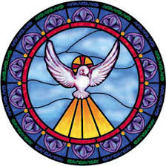

Please pray for the following students as they prepare for their Confirmation on Sunday, April 28, 2019:

Javier Banks | Alma Gyabin
Ephraim Balagun | Lucy Harley
Joel Casey | Ivan Hokens
Madison Chan | Nathan Lau
Elizabeth Chee | Caitlyn Lee
Chloe Culen | Wendy Martinez
Ryan Daly | Alexander Moy
Jacquelline Del Raso | Mathew Schiml
Bruce Garner | Amelia Maya Wong
Xahil Gonzalez | Samantha Woo

