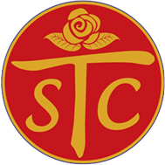
St. Therese Chinese Catholic Parish

Sunday, July 14th
2019
12:00 - 6:00pm






Location: 31st Street Beach
31st Street at Lake Shore Drive
Free 
Summer FUN!

BBQ GAMES FELLOWSHIP

ALL in the Parish are invited!
We especially welcome the visiting Sisters from China as well as other religious communities.


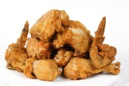


All are welcome to bring a dish to share with the community.




*REQUIRMENT: You MUST REGISTER TO ATTEND. Please register before Monday July 6th by signing up at the church entrance table, or by calling the church office (312-842-6777).
Free BUS SERVICE to Picnic site available at 11:45 & 12:30pm in front of church.
Return bus rides available towards the end of the event.

